Week 05

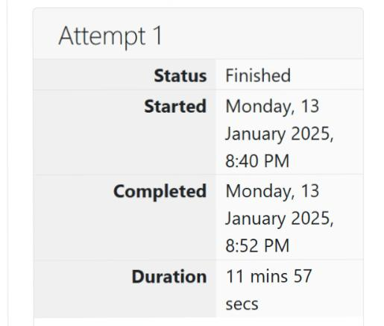

**Question 1:**

**The k-digit number N is an Armstrong number if and only if the k-th power of each digit sums to N.**

**Program:** 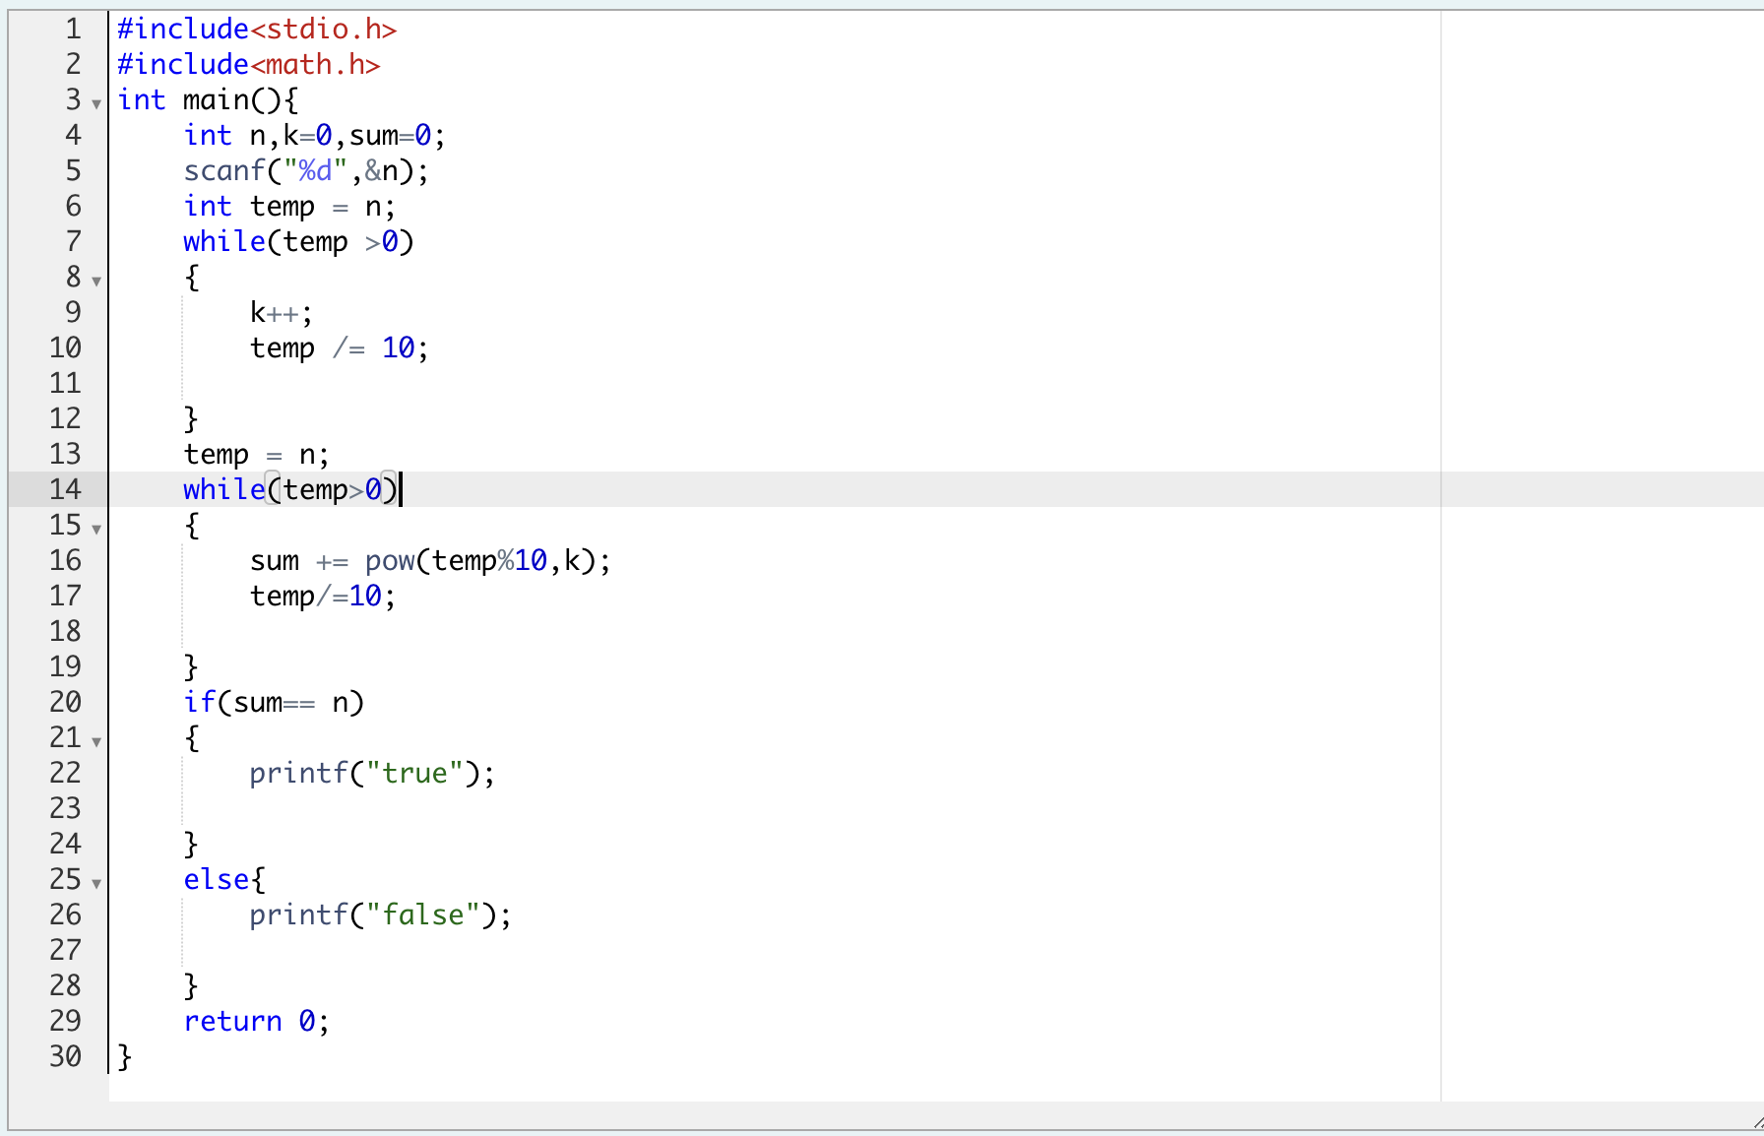

**Output:**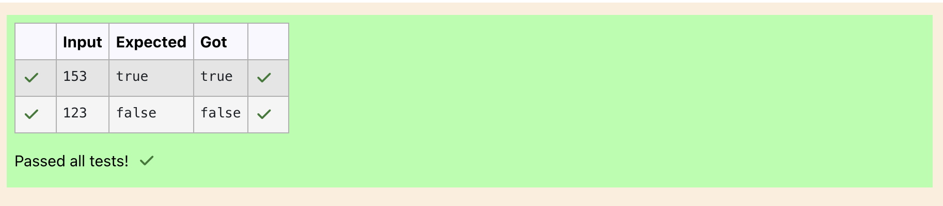

**Question 2:**

**Take a number, reverse it and add it to the original number until the obtained number is a palindrome.**

**Program:** 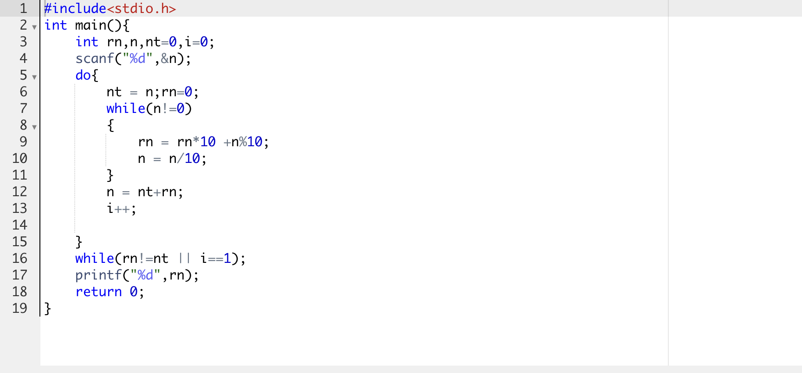

**Output:**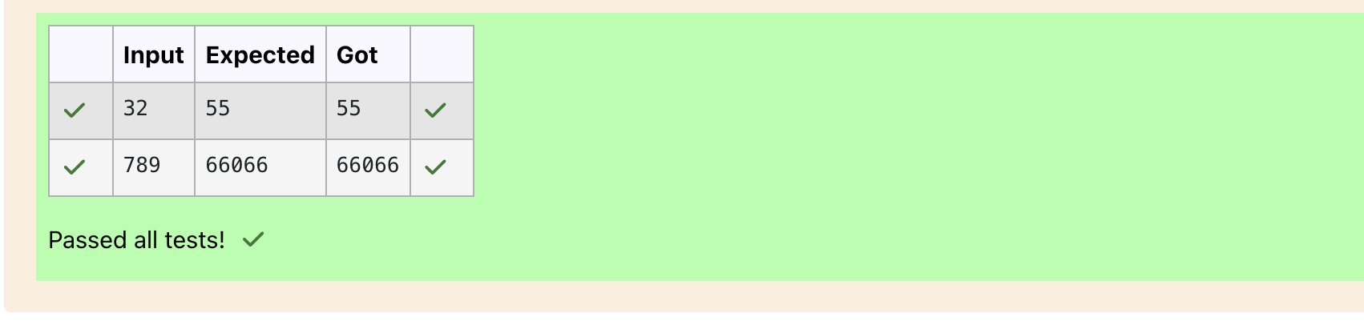

**Question 3:**

**A number is considered lucky if it contains either 3 or 4 or 3 and 4 both in it. Write a program to print the nth lucky number. Example, 1st lucky number is 3, and 2nd lucky number is 4 and 3rd lucky number is 33 and 4th lucky number is 34 and so on. Note that 13, 40 etc., are not lucky as they have other numbers in it. The program should accept a number 'n' as input and display the nth lucky number as output.**

**Program:** 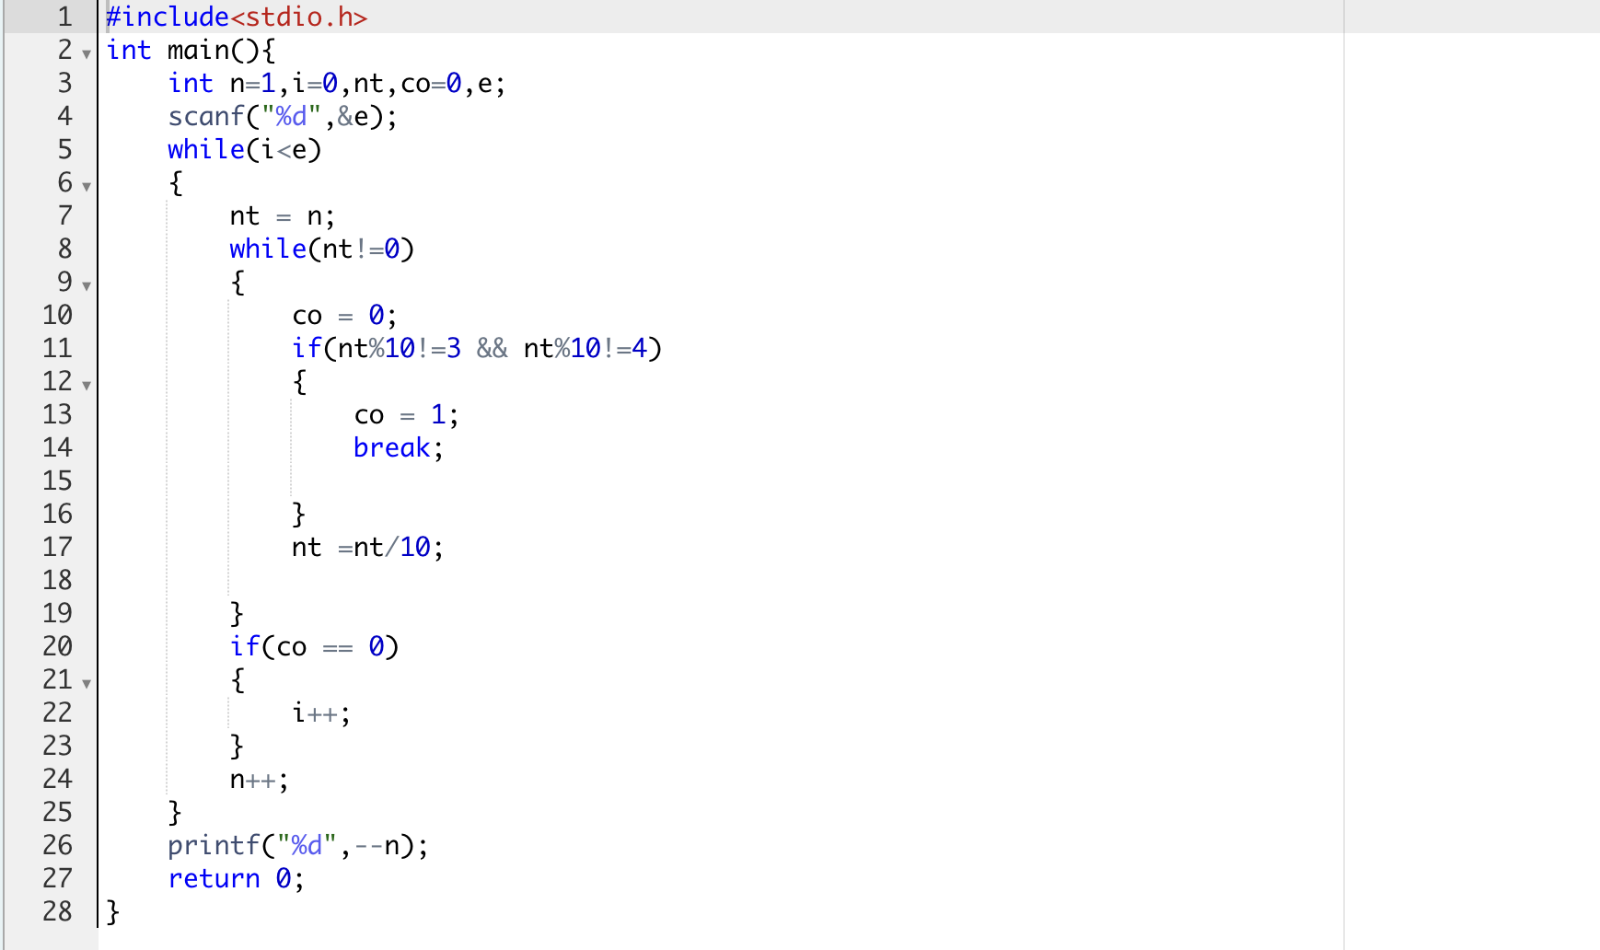

**Output:**

